Tackling Electric Vehicle Accessibility Issues in Campus

--------------------------------------------

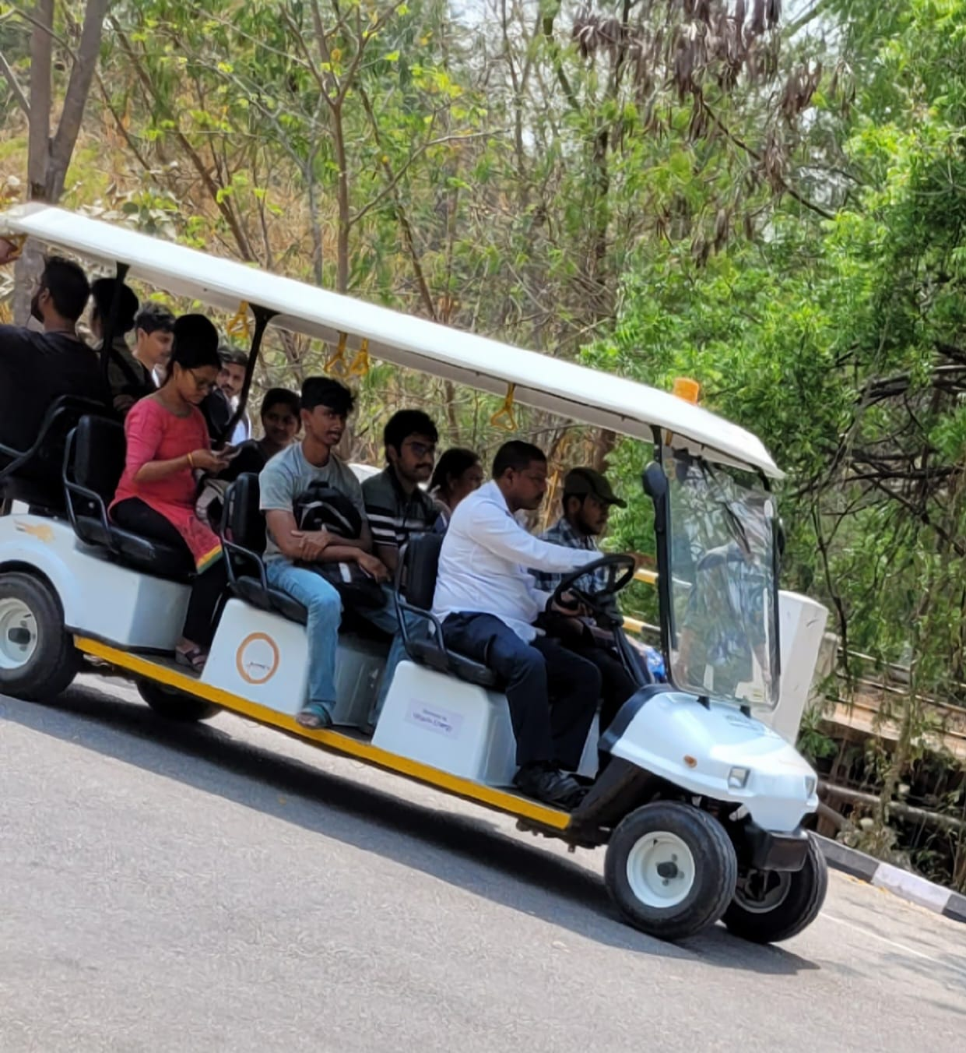

DATE : 03/04/2024

DAY : Wednesday

REPORTED BY :

23MAB0A03- K.AMOGH

23MAB0A09- P.VIGNESH SURYA

23MAB0A23- K.RAHUL

23MAB0A27- D.ABHISHEK

SUMMARY :

This report provides a comprehensive examination of the current transportation system within the NITW campus. It identifies key areas of concern, including efficiency, accessibility. The report further explores potential solutions and improvements, with a focus on sustainability. Recommendations are made based on careful analysis and solutions against best practices in campus transportation worldwide. The ultimate goal is to enhance the transportation facility and experience of students, faculty, and staff, while also reducing the campus’s carbon footprint.

INTRODUCTION :

Transportation plays a pivotal role in the daily operations of any educational institution, and the National Institute of Technology, Warangal (NITW) is no exception. This report shows a detailed analysis of the current transportation system within the NITW campus, observing its effectiveness, the data collected through interviewing, efficiency. The objective is to identify potential areas of improvement and propose better solutions that could improve the commuting experience for all students and staff while also promoting sustainability. By suggesting best practices and considering the unique needs of the NITW community, this report aims to pave the way for a transportation system that is not only robust and reliable.

METHODOLOGY :

* Collecting the information on existing transportation facilities like number of available vehicles, seat capacity of vehicles, statistics regarding charging.
* Interviewing E-vehicle drivers, students and workers who charge them.

DATA ANALYSIS :

|  |  |
| --- | --- |
| QUESTION ASKED | DATA COLLECTED |
| No. of vehicles working properly out of total no. of vehicles available | 1 out of 2 |
| No. of seats per vehicle | 8 seats |
| Time duration for each round | 10-12 minutes |
| Time for full charge of one vehicle | Minimum- 4 hours  Maximum- 8 hours  Average- 6 hours |
| Maximum distance covered for one full charge | 45 Km |

DISCUSSION :

The discussion on the current state of transportation within the NITW campus includes an examination of the existing infrastructure, transportation modes, frequency of service, peak usage times, and areas served. We also looked into the challenges faced by students, faculty, and staff in their daily commute such as delays, overcrowding, and accessibility issues.

CONCLUSION :

In conclusion, this report has provided a comprehensive analysis of the current transportation system within the NITW campus. It has highlighted the key challenges faced by the campus community and the environmental impact of the existing system.We have identified potential areas for improvement and proposed feasible, sustainable solutions. Implementing these changes could significantly enhance the commuting experience, contribute to NITW’s sustainability goals, and improve the overall quality of life on campus.

RECOMMENDATIONS :

* Increase number of vehicles
* Usage of solar energy to charge while vehicle is in use
* Installation of multiple charging points in the campus
* Technical Communication facility between drivers
* Updating the coverage area of the vehicles
* Increase the number of seats per vehicle